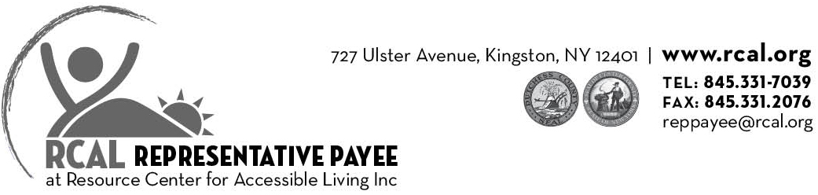

Enclosed please find out Representative Payee packet. Included are:

- Representative Payee Application (pages 2 & 3)
- Release of Information Form (page 4 & 5)
(required because we are an Independent Living Center)
- RCAL Consumer Rights and Responsibilities form (pages 6 & 7)
- Social Security Employment Notification for Rep Payee Individuals & Instruction sheet (pages 8 & 9)
- Representative Payee Acknowledgement (page 10)
- SSA-827 Authorization to Disclose Information (pages 11 & 12)
- SSA-787 Physician's Statement (pages 13, 14 & 15)
- Release of information NYSED ACCES & signature (pages 16 & 17)
- Initial Budget Meeting List (page 18)
Once these forms are completed, please bring or mail them along with letters from any other parties who may have information about your need for a Representative Payee to RCAL. RCAL will complete the SSA-11 to request to be your Representative Payee. After we request to be made Representative Payee, it can be several months before we are appointed your payee by Social Security.
When RCAL is appointed as your Representative Payee, we will schedule a meeting to create a budget with you in order to meet your needs each month. Please see the attached Initial Budget Meeting List for what to bring to the appointment.
If you have any questions, please call the RCAL Representative Payee department at 845-331-7039 or email us at reppayee@rcal.org.

Thank you!
The RCAL Representative Payee Department

Representative Payee Application

First Name | Last Name |  | Social Security Number
Street Address |  |  | City
State | Zip code |  | Telephone
- What is your date of birth?

- What is your gender? Female Male

- What is your primary disability?

- What city were you born in?

- What is your mother's Maiden name?

- What level of education have you completed?
PreK Program  K-8  Some High School  Completed High School  Some College  Business Trade, Vocational School |  | GED Diploma  IEP Diploma  Completed 2yr Undergrad Degree  Completed 4yr Undergrad Degree  Completed Post Graduate Degree
- Are you a veteran? Yes No

- What is your race/ethnicity?
White  African American (non-Hispanic)  Native American or Alaskan Native  2 or more races |  | Asian  Hispanic/ Latino  Native Hawaiian or Pacific Islands  Unknown

Representative Payee Application continued

- What is your current employment status?
Full Time  Part Time  Looking for a job  Unemployed (not looking) | Student or in a program  Retired  Participating in segregated work or day program  Other employment program not specified
- Which best describes where you live?
Alone  In my home  With a relative  With someone else | In a public institution  In a private institution  In a Nursing home  In a board and care facility
- Do you pay rent? Yes. No. If yes, what is your rent? $_______________________________________
Bank Name | Account type (Checking/Savings)
Bank Name | Account type (Checking/Savings)
- Do you have a life insurance policy? Yes. No. If yes, list below:
Insurance Company | Policy Type (Term Life/ Whole Life)
- Do you own a burial plot? Yes. No.
- Do you have Medicare? Yes. No. Medicaid? Yes. No.
- If you have Medicaid, do you have a spend-down? Yes No. If yes, what amount? $_________________
- Do you receive SNAP benefits? Yes No.
- What other types of benefit do you receive? SSI. SSDI. Retirement. Other:

AUTHORIZATION FOR RELEASE OF INFORMATION
Top of Form
RE: | Name |  |  |  |  | Social Security Number
Parent or Guardian’s Name |  |  |  |  |  | Date of Birth
Address |  |  |  | City |  |  |  |  | State | Zip
I hereby authorize and request Resource Center for Accessible Living (RCAL) to: (please check one or both)
Release to Obtain From
Access VR  Devereaux  DSS |  | MHA of Ulster County  Gateway Industries  Ulster G-ARC |  |  | ARC Dutchess County  Social Security Admin  Taconic DDSO |  | MHA of Dutchess  RUPCO  Kingston Housing Auth
Other |  |  |  |  |  | Phone
Other |  |  |  |  |  | Phone
Other |  |  |  |  |  | Phone
Other |  |  |  |  |  | Phone
The following specific information
Specific information to be released BY: |  |  | Specific information to be released TO:
RCAL |  |  | RCAL (This information may include mental health or alcohol or drug abuse records).
All RCAL Records  Intake  ISP/ Narrative / IL Plan  Documentation of disability  Case notes  Information related to Representative Payee  Other |  |  | All Records  SSI / SSDl information  Social History  Alcohol / Drug Assessment  Discharge Summary  Psychological Evaluation  Psychiatric Evaluation  Legal information  Work record  Medical Records  Information related to Representative Payee  Other_____________________________________________________
Specific dates: |  |  | Information to be released in: Verbal form Written form
The purpose for this disclosure is: (check all that apply)
Documentation of Disability | Coordination of Services | Benefits Counseling | Legal
Representative Payee Coordination | Other ___________________________________________
I understand that this consent is revocable at any time prior to the release of this information. This authorization will expire twelve (12) months from the date below or thirty (30) days after termination of services, whichever is sooner. A person has the right to access information generated by RCAL. Copies of the records may be obtained with reasonable notice and may involve a minimal copying cost.
Signature: |  |  |  |  |  |  |  | Date:
If signed by an authorized representative, state relationship and authority.
RCAL authorized Signature

Release of information continued
Contact Information: (This includes any agencies you are currently working with and/or any friends of family you would like RCAL to have contact with. Please add these individuals or agencies to RCAL 's Release of Information form.)

Name | Relationship/Agency Name
Street Address | City
State | Zip | Contact Telephone
Name | Relationship/Agency Name
Street Address | City
State | Zip | Contact Telephone
Name | Relationship/Agency Name
Street Address | City
State | Zip | Contact Telephone
Print Applicant Name
Signature |  |  | Date:
For office use only
Date Received |  | SSA-BK-1 I Complete

Resource Center for Accessible Living Consumer Rights
While you are participating in services offered by the Resource Center for Accessible Living, Inc. (RCAL), you have certain rights regarding information relevant to your situation. Your rights include the expectation of confidentiality, use of appropriate releases, access to your file, and conflict of interest free provision of services.
Confidentiality — It is the policy of RCAL that any information about anyone applyin.9 for services, or admitted and receiving services, is to be held in confidence (i.e., RCAL staff/interns/trainees will not discuss any information about or with anyone outside of RCAL (unless assisting you with applying for agency external agency services i.e. Medicaid, Social Security, OPWDD). The only exception is the Executive Director or assignee sharing information when there is a good faith belief that there is an extreme safety issue (example: possible harm to yourself or others).
Release of Information — Any information obtained or to be disclosed is to be done with the understanding that the information will be confidential and is to be maintained exclusively for the purpose of planning and provision of services. Permission to obtain or release information must be in writing. The release is ongoing for one year, unless termination is requested by you in writing.
Access to Files — You have a right to look at your file. RCAL requests you make an appointment to look at your file at least 48 hours in advance. You may add to or delete information from your record. Due to regulations and legal responsibilities, RCAL may only produce records originally generated by RCAL. Your advocate may assist you in obtaining original information from other sources if requested. However, original records from another source that you provided to RCAL would be available to you when you access your file. These original records would have been marked as originals upon receipt at RCAL.
Conflict of Interest Free Provision of Services — As the local independent living center promoting choice and independence
Resource Center for Accessible Living Consumer Responsibilities
RCAL will provide you with programs and resources to support you regardless of race disability, age, religion, ethnicity, military status, domestic violence victim status, marital status, gender, sexual orientation, gender identity, or economic status in a respectful and professional manner. RCAL will work with you collaboratively to obtain your stated goals as long as you are working cooperatively on the objectives. As RCAL is a consumer-directed agency, your role in exerting independence is integral to the joint effort required to meet your independent living goals and objectives. As a consumer you play an integral role in acquiring services at RCAL because our services are consumer-directed in nature. Therefore, you are responsible for:
- Participating in efforts to exert independence
- Respecting all members of RCAL, including staff, other consumers, and visitors
- Providing, to the best of your knowledge, accurate and complete information about your current state of health and wellness as it applies to receiving supports through RCAL that will help you to become more independent.
- Reporting unexpected changes in your condition that may affect how we assist you, to the responsible Independent Living Advocate
- Communicating whether you clearly understand the scope of available services and what is expected of you.
Keeping your appointments and notifying RCAL staff when you are unable to do so. To cancel or reschedule an appointment with an Independent Living Advocate, call (845) 331-0541.

Consumer Standards of Conduct:
Consumers shall not:
- Engage in any behaviors that constitute abuse: physical, verbal, financial, or emotional to another person.
- Possess dangerous materials, weapons such as firearms, knives, or explosives while on RCAL property, or with RCAL staff, visitors. or associates offsite.
- Engage in criminal conduct including disorderly or obscene conduct while on RCAL property (vandalism, stealing, selling drugs, fighting or threatening violence)
- Smoke on the premises including the parking lot.
- Disregard direction from RCAL staff, volunteers, or associates as it pertains to safety issues.
- Consume alcohol or illegal drugs on the property including the parking lot or come in the building or parking lot intoxicated or high persons who appear to be obviously intoxicated or high may not be allowed access to staff or services.
Grievance Procedure:
If you are not fully satisfied with your experience at RCAL, consumers may use the following methods to address concerns regarding services provided: If you are not fully satisfied with your experience at RCAL, consumers may use the following methods to address concerns regarding services provided:
- Upon receipt of your written request to the Chief Operating Officer, you may request, without prejudice, another Independent Living Advocate. This Advocate will be assigned to you within 5 business days of receipt and will remain the sole coordinator for the services you request.

- If you are unsatisfied with the service, you may first request in writing a meeting with your Independent Living Advocate; you may also request that their Supervisor be present to hear your concerns. This meeting will be scheduled at your earliest convenience within two weeks of receipt of your letter.
- Should you still be unsatisfied, after the initial meeting, with the service, you may request to speak to the Compliance Officer, call (845) 331-0541, extension 16. Upon receipt of a phone call the Compliance Officer will return your call within 3 business days.
- You may request to speak to the Executive Director, if you remain unsatisfied with the service. Upon Receipt of your phone call the Executive Director will return your call within 3 business days or as soon as possible if the Executive Director is out of the office.
- You may choose to bypass these options and directly contact ACCES-VR offices at:
Rookmini Mangal MSEd., CRC, Vocational Rehabilitation Counselor NYS Education Department
89 Washington Avenue, Albany, NY 12234
P: (518) 486-3777 F: (518) 473-6073
Consumer Signature |  |  | Date
Print Consumer Name |  | Staff Signature

Wage Notification Instruction Sheet

As an individual who receives benefits from Social Security, you are required to report your wages each month to Social Security. As your Representative Payee, this is a service that RCAL may provide. Please see the attached information sheet.
If you choose RCAL to provide notification to Social Security:
- Complete the Social Security Employment Notification for Representative Payee Individuals form indicating that you would like RCAL to notify Social Security and return it to RCAL.
- Provide RCAL with copies of your pay stubs by the last week of each month.
If you choose to notify Social Security of your wages:
- Complete the Social Security Employment Notification for Representative Payee Individuals form indicating that you would like to notify Social Security of your wages and return it to RCAL.
- Notify Social Security in the following ways by the 10th of the month following the month worked. To find out how to go about reporting your wages please call your local Social Security office at 1-877-405-6747. They have several different options available for wage reporting.

Social Security Employment Notification for
Representative Payee Individuals

RE:
Date

As the Representative Payee, Social Security requires that the Resource Center for Accessible Living, Inc. (RCAL) provide them with a monthly report of the wages earned by persons receiving Social Security funds. Below please provide us with information regarding your employment. You may choose to provide notification to Social Security yourself. If that is the case, please indicate that below.

Please be aware that FAILURE TO NOTIFY SOCIAL SECURITY of your income could result in
TERMINATION OF YOUR BENEFITS.

Name of Employer
Date Employed
Hours scheduled per week
Hourly wage $
PAID | Weekly | Biweekly | Bimonthly | Monthly
Please choose one
- I authorize RCAL to notify Social Security of my monthly wages. I will provide RCAL with paystubs by no later than the last week of each month.
- I DO NOT authorize RCAL to notify Social Security of my monthly wages. I will notify Social Security myself. I understand that FAILURE TO NOTIFY SOCIAL SECURITY of my income could result in TERMINATION OF MY BENEFITS.

Signature
Signature of RCAL Representative

Representative Payee Acknowledgement

I understand that by signing and submitting these documents I am acknowledging that I am requesting that RCAL be appointed as my representative payee. I further authorize RCAL to submit the SSA-BK-11 form on my behalf to The Social Security Administration (SSA) in order to have RCAL appointed as my representative payee.

Print Applicant Name
Client Signature | Date
RCAL Staff Signature | Date

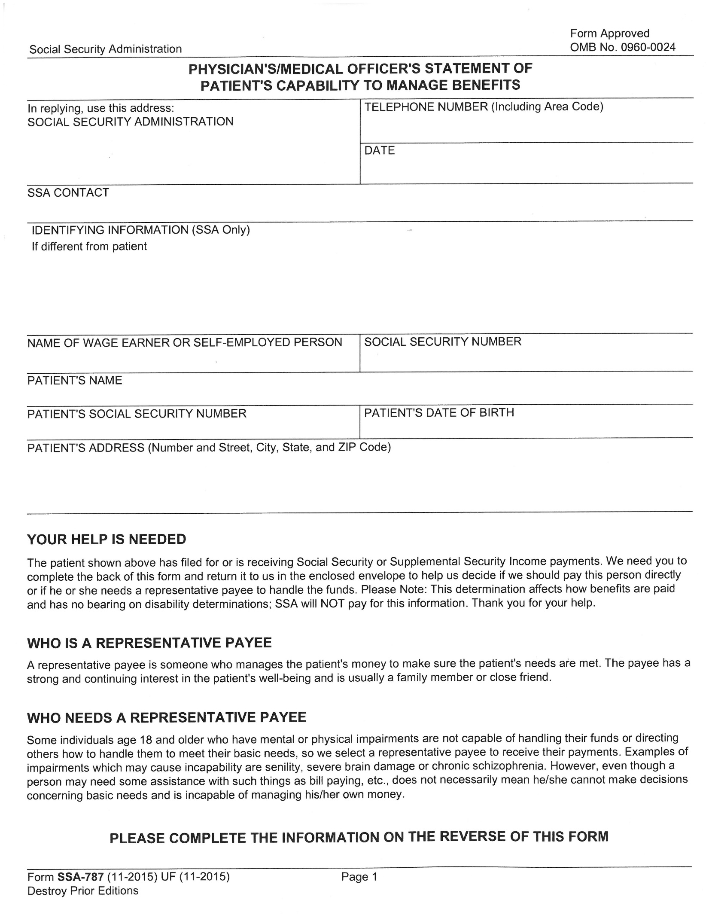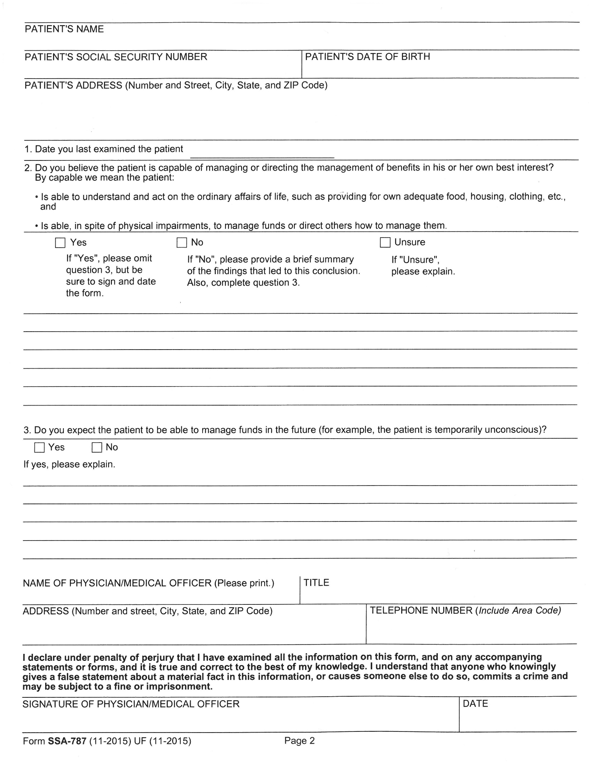

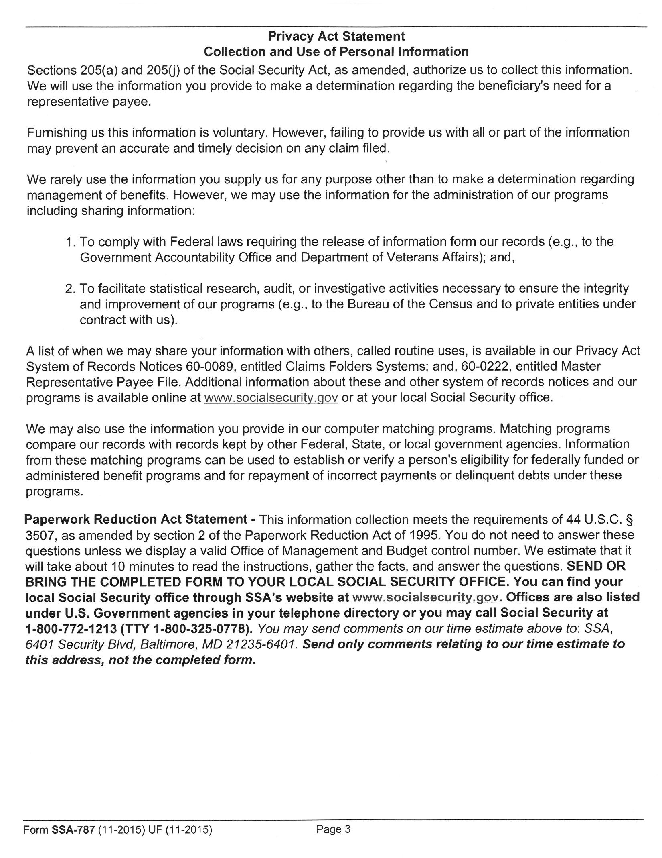

Release of Information (AUTHORIZATION PERTAINING TO NYSED ACCES)

Consumer Name | Date of Birth
By signing this form, you authorize Resource Center for Accessible Living, Inc. (RCAL) to allow the review of your consumer file and protected health information by the New York State Education Department's Office of Adult Career and Continuing Education Services.

As an Independent Living Center (ILC), our agency receives funding through NYSED ACCES. NYSED ACCES has the obligation to monitor that our services meet certain eligibility criteria and standards pursuant to state and Federal law. The information reviewed will only be used for the pu1poses, set forth below, and will only be used and shared by authorized ACCES staff.

What information will be reviewed?
The following information:
Entire contents within your file for the purpose of monitoring, by NYSED ACCES, of Independent Living Inc.'s compliance with the eligibility requirements for ILCs and compliance with the CIL (Centers for Independent Living) Standards, including the following: Date of Birth; Gender; Race/Ethnicity (if provided); Employment and Education status; County where you reside; Veteran status and Disability information. Required documents, such as Consumer Rights and Responsibilities, Consumer Grievance, Individual Authorizations (Consents) and Documentation of Services will also be reviewed.

Please note: Information within your file will only be reviewed, and no contents of your file shall be removed, nor will any copies be made for this NYSED ACCES review.

You have a right to decline this authorization. Your services, the payment for your services, and your health care benefits will not be affected if you choose to decline. If you sign this form, you will have the right to revoke it at any time, except to the extent that the Independent Living program has already taken action based upon your authorization. To revoke this authorization, please write to the Chief Operating Officer of the Independent Living program in which you participate.

When will this authorization expire?
This authorization shall remain in effect for one year beyond the date it is signed unless it is revoked in writing.

USE AND DISCLOSURE COVERED BY THIS AUTHORIZATION
Please Check for Authorization or Declination:
I hereby AUTHORIZE Resource Center for Accessible Living, Inc. and/or its Representatives
I DECLINE to give authorization to Resource Center for Accessible Living, Inc. and/or its Representatives
To submit my file for REVIEW ONLY by the agency, individual, or employer identified below:
Name/Title or Organization: NYSED ACCES
Address: 89 Washington Avenue, Room 580 EBA, Albany, NY 12234
Phone: (518) 474-2925 | Toll Free: 1-800-222-5627 | Fax: (518) 473-6073

Signature

I have read this form and all my questions about this form have been answered.
Signature of Consumer or Authorized Representative
Printed Name
Date
Description of Authorized Representative's Authority (Legal Guardian, etc.)

Things to bring to Initial Budget Meeting

- Bank Statement
- Rental agreement or letter stating rental amount from landlord.
- Bills
  - Utilities (such as cable, electric, oil, or gas)
  - Cell Phone
  - Credit cards
  - Medical Bills
- Outstanding Loans (either the loan agreement or a letter signed by the lender; include amount due.)
- Insurance bills (medical or auto)
- Bereavement policies or already purchased burial plots.
- Life insurance policies
- Pay stubs

